EXP 14 : **E-Commerce Registration System**

**AIM :** To draw UML diagram for E-Commerce Registration using umbrello.

**ACTIVITY DIAGRAM:**

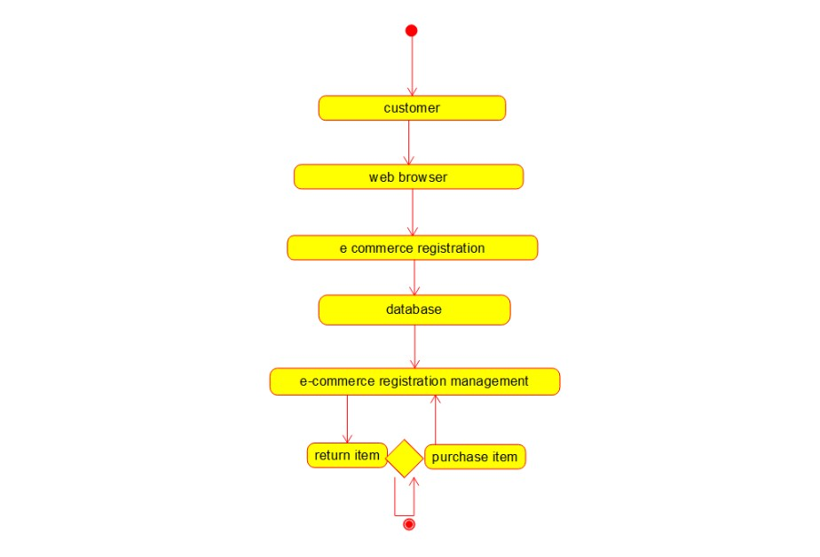

**SEQUENTIAL DIAGRAM :**

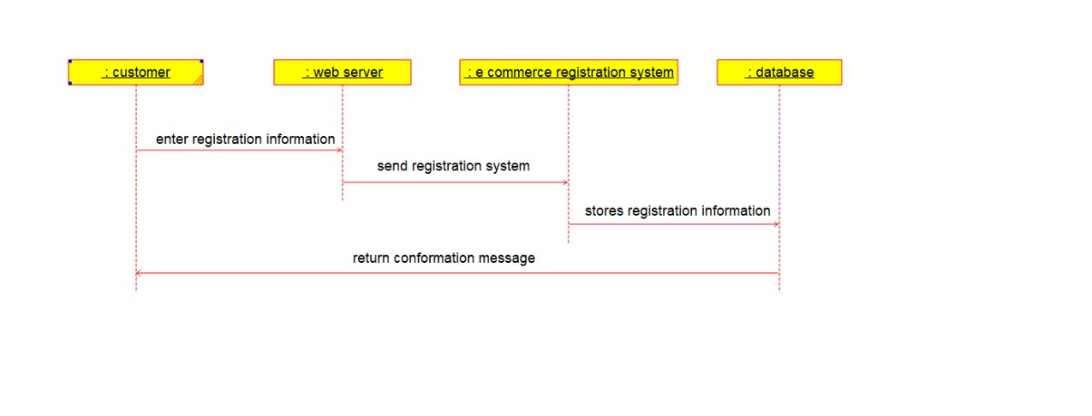

**COLLABRATION DIAGRAM:**

